**ACESULFAME**

**Nomenclature**

**IUPAC Name:** 6-methyl-2,2-dioxooxathiazin-4-one

**Structure:**

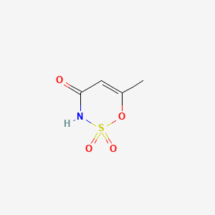

**Molecular Formula**: C4H5NO4S

**Molecular weight**: 163.15 g/mol

**CAS No**: 33665-90-6

**General Properties**:

Description:

Acesulfame is a sulfamate ester that is [1,2,3-oxathiazin-4(3H)-one 2,2-dioxide](https://pubchem.ncbi.nlm.nih.gov/compound/1%2C2%2C3-oxathiazin-4%283H%29-one%202%2C2-dioxide) substituted by a methyl group at position 6. It has a role as a xenobiotic, an environmental contaminant and a sweetening agent. It is a sulfamate ester, an organonitrogen heterocyclic compound, an oxacycle and an organic heteromonocyclic compound.

**Indication:**

Acesulfame potassium retains its sweetness at a wide range of temperatures and in many food-processing conditions, which allows it to be used as an ingredient in a variety of food products, including baked goods, beverages, candies, chocolates, dairy products, desserts, and more.